CSE 3002 – INTERNET AND WEB PROGRAMMING
Ex No: 5
DHRUBANKA DUTTA - 17BCE1019
Date: 23.1.19
FACULTY : DR. SANDHYA P.

a. Fetch a number using HTML form and using JavaScript function check if it is a Krishnamoorthy number.
A krishnamoorthy number is a number such that the sum of the factorial of the digits of the number is equal to the number itself.
e.g. 1!+4!+5+=145

CODE:

<!DOCTYPE html>
<html>
<head>
<title>
LAB 5 QUESTION A
</title>
<script>

function factorial(num)
{
var fact = 1;
if(num<0)
return 0;
else
{

for(var i=num ; i>1 ; i--)
fact*=i;
return fact;
}
}

function krishna() {
var number = document.getElementById("i").value;
var answer;
var number1 = parseInt(number);
var sum = 0;
var checksum = number1;
while (number1>0) {
digit = number1%10;
number1 = parseInt(number1/10);

term = factorial(digit);

sum = sum + term;
}

if(sum == checksum) {
answer = "Krishnamoorthy Number";
} else {
answer = "Not Krishnamoorthy Number";
}
document.getElementById("result").innerHTML = answer;
}
</script>
</head>
<body>

<form>
Enter Number:<br>
<input type="text" id="i">
<br><br>
<input type="button" onclick="krishna()" value="click" >
</form>

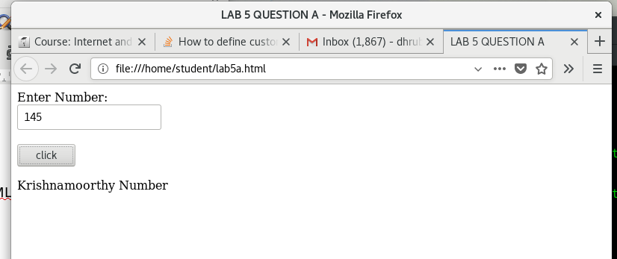

b. Fetch an array and sort it using JavaScript user-defined functions.

CODE:
<!DOCTYPE html>
<html>
<head>
<title>
LAB 5 B - ARRAY SORT
</title>

</head>
<body>

<p id = "data"></p>
<p id = "result"></p>
<button type="button" onclick="bubble_sort(test)">CLICK TO SORT ARRAY</button>

<script>

var test = [83,54,91,33,21,44];
document.getElementById("data").innerHTML = "Original Array : " + test.toString();

function swap(arr, first_Index, second_Index){
var temp = arr[first_Index];
arr[first_Index] = arr[second_Index];
arr[second_Index] = temp;
}

function bubble_sort(test){

var len = test.length,i, j, stop;

for (i=0; i < len; i++){
for (j=0, stop=len-i; j < stop; j++){
if (test[j] > test[j+1]){
swap(test, j, j+1);
}
}
}

document.getElementById("data").innerHTML = "New Array : " + test.toString();
}

</script>

</body>
</html>

